Practical
SUMMARY:-
The program uses Prim’s Algorithm to find the Minimum Spanning Tree (MST) of a weighted graph. It starts from vertex 0 and repeatedly selects the minimum-weight edge that connects a visited vertex to an unvisited vertex. Finally, it prints all MST edges and the total weight.
Output:
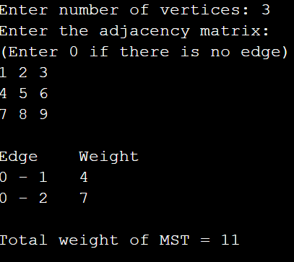
Time Complexity
Case | Time Complexity
Best Case | O(V²)
Average Case | O(V²)
Worst Case | O(V²)

Space Complexity
O(V) for the parent, key, and visited arrays.
Including the adjacency matrix, the total space required is O(V²).
Conclusion:
Thus, Prim’s Algorithm successfully finds the Minimum Spanning Tree of a connected weighted graph. It selects the minimum-cost edges without forming a cycle and calculates the minimum total weight of the MST.

